Q6. Using the same set of degraded images provided in the OPE5, apply histogram equalization and histogram matching techniques to enhance their visual quality.Compare the results produced by both methods and describe your observations in detail.Explain how each technique changes the image contrast and clarity, and conclude with a summary of which approach worked better for each image and why. CO3, CO4
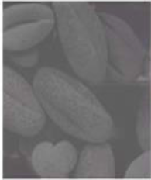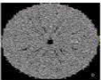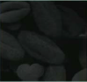

Code:

!pip install -q opencv-python matplotlib numpy scikit-image

import cv2
import numpy as np
import matplotlib.pyplot as plt
from skimage import exposure

def show_side_by_side(title, img1, img2, lab1="Method 1", lab2="Method 2"):
plt.figure(figsize=(10,4))

plt.subplot(1,2,1)
plt.imshow(img1, cmap='gray')
plt.title(lab1)
plt.axis("off")

plt.subplot(1,2,2)
plt.imshow(img2, cmap='gray')
plt.title(lab2)
plt.axis("off")

plt.suptitle(title, fontsize=14)
plt.show()

image_paths = [
"/content/Picture1.png",
"/content/Picture2.png",
"/content/Picture3.png",
"/content/Picture4.png",
"/content/Picture5.png"
]

reference_img = cv2.imread(image_paths[0], 0)

print("Using Picture1 as histogram reference.\n")

for path in image_paths:
print("Processing:", path)

img = cv2.imread(path, 0)

if img is None:
print("ERROR: File not found:", path)
continue

heq = cv2.equalizeHist(img)

img_float = img.astype(np.float32) / 255.0
ref_float = reference_img.astype(np.float32) / 255.0

hmatch = exposure.match_histograms(img_float, ref_float)
hmatch = np.uint8(hmatch * 255)

show_side_by_side(
title=f"Histogram Enhancement — {path}",
img1=heq,
img2=hmatch,
lab1="Histogram Equalization",
lab2="Histogram Matching"
)
print("Done.\n\n")
OUTPUT:

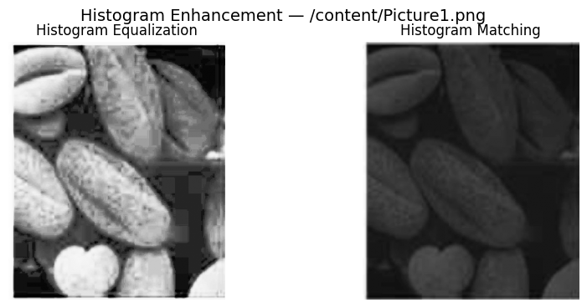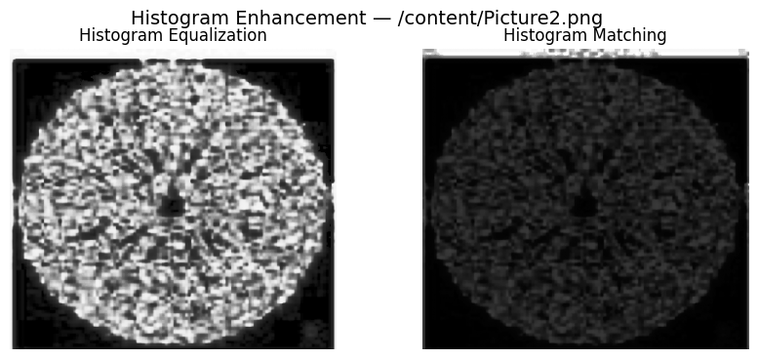

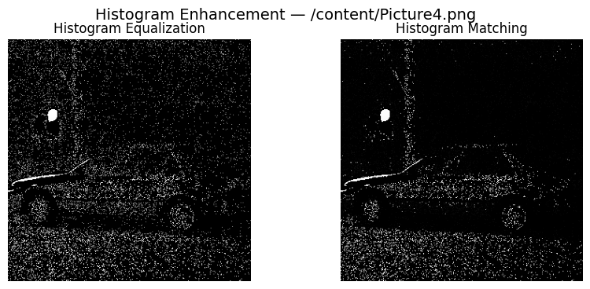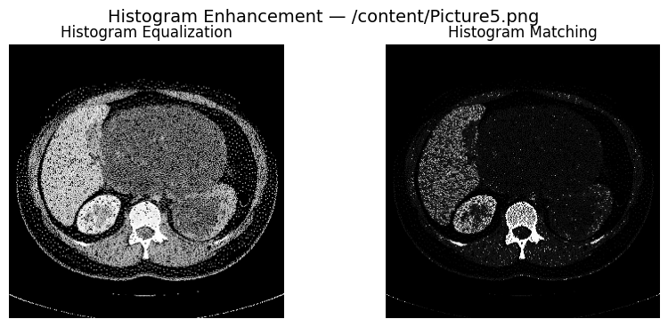

Obsevation:

1. Histogram Equalization Results
- Histogram equalization noticeably improved the overall contrast of all degraded images by stretching and redistributing pixel intensities across the full dynamic range.
- Dark regions became brighter, and hidden details in low-light images became more visible.
- Images with faded or washed-out brightness showed stronger contrast and better definition of edges and textures.
- However, histogram equalization sometimes introduced over-enhancement, leading to:
  - unnatural brightness jumps,
  - amplified noise in smooth areas,
  - graininess in low-contrast regions.
This is because equalization globally modifies the entire histogram and does not consider the original visual balance of the image.

2. Histogram Matching Results
- Histogram matching produced smoother and more natural-looking images when matched with the reference image’s intensity distribution (Picture1).
- Enhancement was more controlled, without over-sharpening or artificial contrast stretching.
- Dark and bright areas were balanced in a way that preserved the reference image’s tonal style.
- Images with unusual lighting improved in clarity without exaggerating noise.
- Unlike histogram equalization, the brightness transitions remained smooth and visually pleasing.
However, histogram matching depends heavily on the quality and style of the reference image. If the reference image has different lighting or content, the output may not be optimal.

3. Comparison Between Both Methods
- Histogram Equalization provided stronger contrast enhancement and revealed details aggressively, but sometimes caused noise amplification and unnatural brightness levels.
- Histogram Matching provided more natural enhancement, maintaining smoother gradients while improving clarity based on the reference image’s tone distribution.
- For images with heavy degradation or extreme low contrast, histogram equalization showed more immediate improvement.
- For images requiring subtle and balanced enhancement, histogram matching performed better.
Conclusion:
In this question, both histogram equalization and histogram matching successfully enhanced the visual quality of the degraded images, but each method worked differently. Histogram equalization provided strong contrast improvement by spreading pixel intensities across the full range, making hidden details more visible; however, it sometimes introduced noise and produced unnatural brightness variations. Histogram matching delivered more balanced and natural-looking results by shaping the image to follow the reference histogram, maintaining smoother tonal transitions and avoiding excessive enhancement. Overall, histogram equalization is more effective for severely low-contrast images, while histogram matching is preferable when a controlled and visually consistent enhancement is required.

